More Information About the Socioeconomic Peace Index Tool
The Socio-Economic Peacebuilding Index (SEPI) is a composite indicator developed by the The United Nations Development Programme (UNDP) Istanbul International Centre for Private Sector in Development (ICPSD) to measure the structural socio-economic conditions associated with conflict vulnerability in the Horn of Africa with a focus on Somalia, South Sudan, and Kenya. SEPI is grounded in relative deprivation theory which states that the gap between perceived entitlements and actual conditions creates grievances that can escalate into collective violence under certain socioeconomic conditions.
SEPI is designed to support development actors, government partners, and donors in identifying where integrated peacebuilding and development investments are most urgently needed in order to develop the conditions for sustained peace.
SEPI is calculated at the Admin-1 (provincial/state) level across Kenya, Somalia, and South Sudan. A high SEPI score reflects how a region has better structural conditions relative to other regions in the same country.

What does the map show?
Each Admin-1 region is shaded on a spectrum from lower capacity (regions with the most deprived socio-economic conditions relative to their country peers) to higher capacity (regions with the strongest relative structural conditions). Five underlying pillars drive the composite score:
Pillar | What it captures
Education Index | School attendance, literacy, school access, teacher presence
Food Security Index | Share of population in IPC Crisis or Worse (Phase 3+)
Poverty Reduction Index | Poverty headcount, income/expenditure per capita
Health Access Index | Healthcare access, health facility density, hospital density
Climate Resilience Index | Vegetation health, soil moisture, drought severity

Hovering over or clicking a region on the map reveals its composite SEPI score, its within-country rank, and its five pillar scores.

Methodology
The Socio-Economic Peacebuilding Index (SEPI) integrates multiple indicators of structural socio-economic capacity to create a comparative assessment tool for peacebuilding programming.

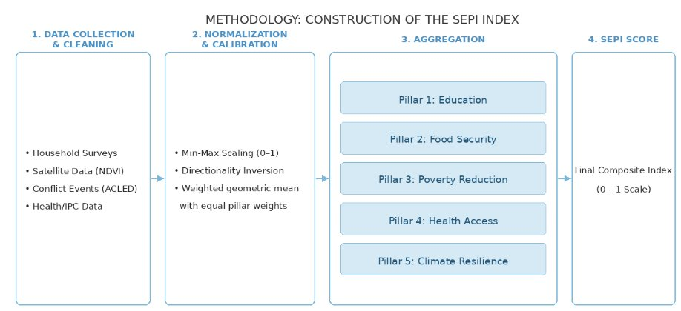
1. Data Collection & Cleaning: Data is gathered from multiple reliable sources, including household surveys, remote sensing, and international databases. Candidate indicators are reviewed for domain coverage, data quality, and statistical independence.
2. Normalization & Calibration: All indicators are rescaled to a common [0, 1] range using min-max normalization (with polarity adjustments if needed).
3. Aggregation: Normalized indicators are grouped into five thematic pillars - Food Security, Education, Health, Poverty Reduction, and Environment. Each pillar score is the arithmetic mean of its indicators, with equal weight assigned to each.
4.SEPI Score: The five pillar scores are combined into a single composite score using a geometric mean with equal pillar weights.
5.Validation: SEPI scores are validated against two external criteria - ACLED conflict intensity data (testing whether lower scores are associated with higher conflict levels) and IOM displacement tracking data (testing whether lower scores are correlated with higher displacement pressure). Robustness is assessed by re-running the index with alternative normalization methods and weighting schemes and measuring rank stability.
6. Visualization: Results are displayed through interactive maps and dashboards enabling users to explore composite scores, individual pillar breakdowns, and raw indicator values at the Admin-1 level.

Data sources
Pillar/ Categories | Source | Coverage years
Food Security | IPC / HDX HAPI | 2024–2025
Education | Kenya Population and Housing Census; Somalia SIHBS; South Sudan National Education Census | 2019–2022
Health Access | Government of Kenya; WHO health facility database | 2024–2025
Poverty Reduction | OPHI; Kenya National Bureau of Statistics; Somalia NBS; South Sudan Poverty and Equity Assessment; CLiMIS South Sudan | 2022–2024
Education and Healthcare Accessibility | Heidelberg Institute for Geoinformation Technology | 2025-2026
Climate Resilience / Environment | Google Earth Engine Data Catalog | 2023–2024
Administrative boundaries | UN OCHA COD | —
Conflict | ACLED API | 2016–2025

Conflict Data
Event counts and fatalities were derived from ACLED data spanning January 2016 to December 2025, incorporating three event types: Battles, Explosions/Remote Violence, and Violence against Civilians.
ACLED definitions of event types:
Battles: A violent interaction between two organized armed groups at a particular time and location. Battles can occur between armed and organized state, non-state, and external groups, and in any combination thereof.
Explosions/Remote violence: Incidents in which one side uses weapon types that, by their nature, are at range and widely destructive.
Violence against civilans: Violent events where an organized armed group inflicts violence upon unarmed non-combatants.

What is ACLED?
ACLED (Armed Conflict Location & Event Data) is an independent global monitor that collects, analyses, and maps data on conflict and protest. ACLED provides detailed information to help identify, understand, and track patterns and trends in conflict and crisis situations around the world.
ACLED only records estimated fatalities when reported by the source material. Where possible, researchers triangulate fatality figures, but ACLED does not independently verify them.
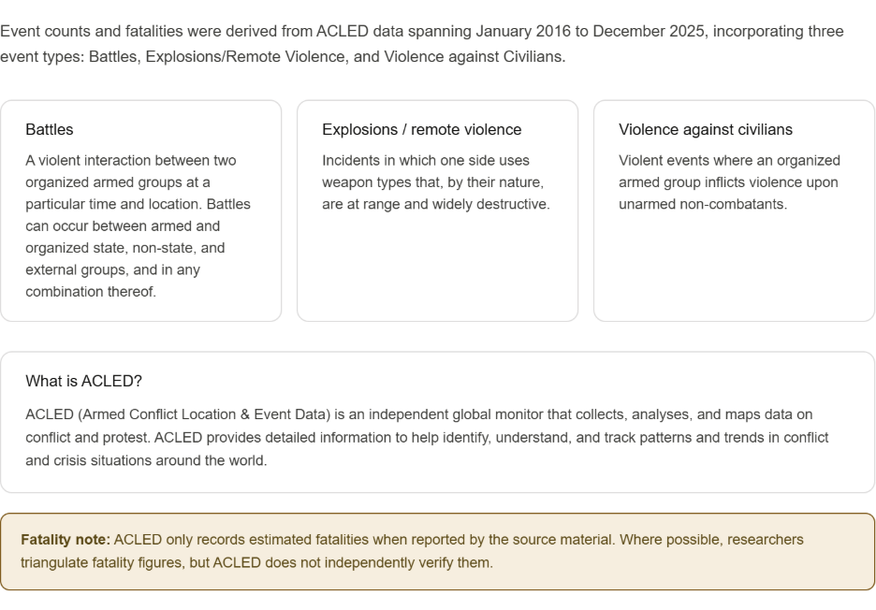

Key Indicators
Which indicators did we choose to build SEPI?
Pillar | Kenya | Somalia | South Sudan
Education | Primary school net attendance (%) + Secondary school net attendance (%) + Population with school access (%) | Literacy rate (%) + Primary net attendance (%) + Secondary education attainment (%) + Population with school access (%) | Population with school access (%) + Teachers on payroll (%) + Student dropout rate (%)
Health | Population with healthcare access (%) + Health facilities per 10k pop + Hospitals per 100k pop | Population with healthcare access (%) + Health facilities per 10k pop + Hospitals per 100k pop | Population with healthcare access (%) + Health facilities per 10k pop + Hospitals per 100k pop
Food Security | Population in IPC Phase 3+ | Population in IPC Phase 3+ | Population in IPC Phase 3+
Economic | Poverty headcount (%) + Gross county product per capita (KSh) | Poverty headcount (%) + Household expenditure (USD) | Poverty headcount (%) + Avg. minimum consumption basket cost (USD)
Environment | NDVI + Soil moisture anomaly + FAPAR anomaly + Palmer Drought Severity Index | NDVI + Soil moisture anomaly + FAPAR anomaly + Palmer Drought Severity Index | NDVI + Soil moisture anomaly + FAPAR anomaly + Palmer Drought Severity Index
All indicators contribute positively to the SEPI score, except for the following, which have a negative polarity (higher values reduce the score): Population in IPC Phase 3+, Poverty headcount (%), Student dropout rate, and Average minimum consumption basket cost (USD)

FAQ
Why use a geometric mean across pillars instead of a simple average?
The geometric mean ensures that all five dimensions matter and that a high score in one pillar cannot compensate for a low score in another. With a simple arithmetic average, a region that completely fails on food security can still receive a mid-range score if it scores well on health and education. The geometric mean prevents this masking effect — a near-zero score on any single pillar substantially depresses the final score. This reflects the design premise that peacebuilding capacity requires a baseline across all structural dimensions.
How are the sub-indicators weighted?
Each pillar contributes equally to the composite score. Within each pillar, the score is the arithmetic mean of its indicators, meaning each subpillar indicator contributes the same fraction (1 / number of indicators) to the pillar score. This is a deliberate transparency choice: equal weighting is reproducible, auditable, and it prevents subjective judgments regarding ranking criteria such as "primary school enrollment rate is more important than school accessibility."
Are scores comparable across Kenya, Somalia, and South Sudan?
No, SEPI scores are min-max normalized within each country, so the reference distribution differs between countries. A score of 0.65 in Kenya and 0.65 in South Sudan reflect different raw underlying conditions.
What years does the data cover?
Data sources span 2019–2026.
- Food security data (IPC): 2024–2025
- Health facility data: 2024–2026
- Education data: 2019–2026
- Economic indicators: 2022–2024
- Climate indicators: 2023–2024
See the full sources through clicking each subpillars.
Is conflict data included in the SEPI score?
No, conflict data (ACLED) is used only to validate the index after construction — to test whether lower SEPI scores predict higher conflict intensity and displacement.

How to cite this index
UNDP ICPSD Crisis Resilience Team. (2025). Socio-Economic Peacebuilding Index (SEPI). Admin-1 level composite indicator for Kenya, Somalia, and South Sudan. United Nations Development Programme. Available at: https://github.com/m-szigeti/Socioeconomic-Peace-Index-Tool

Access the data and code
All scores, pillar breakdowns, raw sub-indicator values, and methodology documentation are openly available:
- GitHub repository: https://github.com/m-szigeti/Socioeconomic-Peace-Index-Tool & https://github.com/crisis-resilience/sepi

